Cooperative Online International Learning project (COIL) - ZIKA Outbreak in the United States, Ecuador, and Venezuela years 2015-2019
Kamila Arap, Andres Eskenazi, Prachi Lalwani, Gracie Pietz, Daniela Valdes Posada.
Florida International University

Author Note
Sponsored by the American Council on Education and Florida International University’s Honors College.

Table of Contents

Executive Summary 3
Introduction 4
Cumulative Incidence 5
Ecuador 6
United States 6
Venezuela 7
Communication Strategies 8
The United States & Ecuador 8
Venezuela 9
Stakeholder Actions 10
Ecuador 10
United States 10
Venezuela 11
Analysis of Issues and Effects by Country 12
United States 12
Ecuador 14
Venezuela 16
Interviews with Regional ZIKA Experts: 20
Policy Proposals 22
Monitoring Ports of Entry 22
Protecting Health Infrastructure 24
Conclusion 27

Executive Summary
Biomedical, Communicational, and Public Policy strategies likely portray the flaws and solutions to the ZIKA epidemic in Latin America and the United States. Governments are responsible for delegating agencies and ministries to effectively solve crises in their countries. In each of the three countries, Biomedical, Communicational and Public Policy strategies had a strong correlation to the eradication of the virus. Ecuador had strong biomedical and public policy strategies, working closely with USAID development projects to create clinics and research centers to contain diseases, however their communication strategies were centered around the capital and did not reach the affected rural areas. Meanwhile, The United States spearheaded all three strategies with a congressionally approved $1.1Billion ZIKA funding bill despite bureaucratic setbacks. Venezuela, on the other hand, had very centralized policy making decisions and lack of transparency with reported incidence cases could not accurately predict how much help was needed in the country. To this day, it is the only country with recurring cases of ZIKA. Overall, all three countries portray how balancing these three key strategies aid in eradicating an epidemic.

Introduction
Zika is a virus spread by the bite of an infected Aedes species mosquito (Ae. aegypti and Ae. albopictus). There is no current vaccine for Zika, which makes the disease difficult to contain in an international outbreak, as shown by the most recent one in 2016 throughout Latin American countries and the United States. Zika’s greatest effect is on pregnant women, causing birth defects. Due to poor health infrastructure, lack of effective governmental communication and ineffective policies, developing countries did not contain the virus efficiently, which increased the risk of a pandemic. This created issues for the United States as well, because commerce and immigration between Latin America and the United States made it easier for the virus to spread. This paper provides a comparative analysis of the Zika outbreak in Ecuador, Venezuela and the United States. It was completed in two sections: analysis and proposals. The research component provides comparative analyses of the reaction each country had to the outbreak of the Zika virus.
The second part provides country-specific stakeholder and US-centered policy proposals. Resources used for research included government publications from Ecuador, Venezuela, and the United States provided by NGOs, think tanks, and interviews from regional experts in the public policy, communication, and biomedical fields in Latin America. The stakeholder and policy proposals reflect the research conducted and provide crucial information for future prevention and containment of epidemics between the United States and Latin America.

Cumulative Incidence
Cumulative incidence calculates the numbers of new cases of a disease during a specific time, divided by the number of subjects at risk in the population.Cumulative Incidence reports in Venezuela, Ecuador and the United States are important to provide accurate tracking and progression of the epidemic. This helps the UN in allocating funds for resources as well.

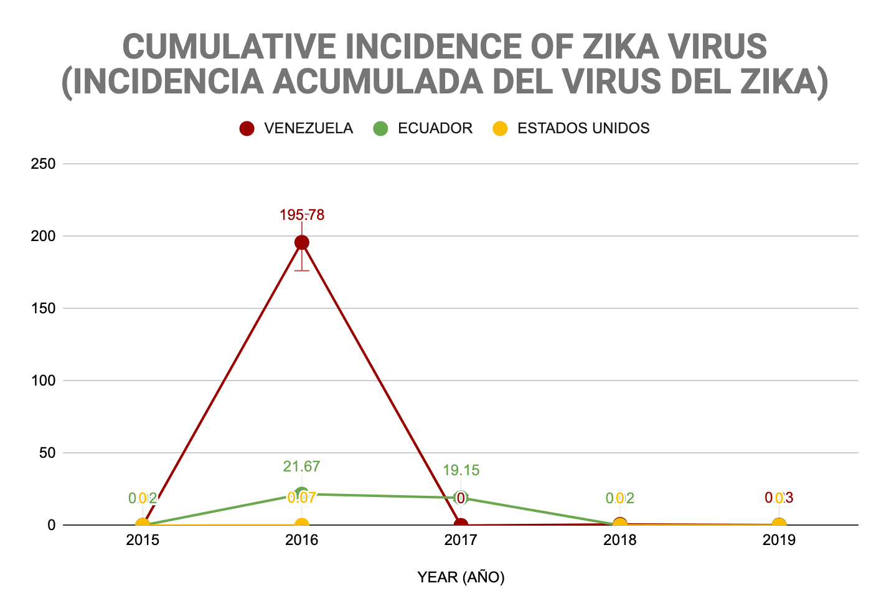
Figure 1 Cumulative Incidence of ZIKA virus.

Note: The graph above, the cumulative incidence of the ZIKA virus in the United States, Ecuador, and Venezuela from 2015 to 2019 is shown. Cumulative incidence shows us how the risk of contracting the disease based on the country’s population during a period.

Ecuador
Ecuador’s government collaboration with the United States and high altitude likely suggests the low cumulative incidence frequency. As Shown in Figure 1, Ecuador did not have any missing figures of cumulative incidence and their rates of ZIKA were not as high throughout the years 2015-2019. This likely relates to the difference in government structures between Ecuador and Venezuela, and their relationship with the United States. While Venezuela relied on national and International assistance, Ecuador worked closely with USAID to combat the virus. Ecuador’s high altitude proved to also be a key factor in the low number of cases, because mosquitoes thrive in more humid tropical climates.

The United States
The United States likely became vulnerable to the ZIKA Virus through “imported” cases from Latin American countries. Individuals who traveled to affected areas exported the disease in small amounts to US border states with high migration from Latin America like Texas and Florida.The presence of cases was never significant in comparison with the population size, as shown in figure 1.

Venezuela
As shown in figure 1, the Venezuelan government likely tried to conceal the number of reported cases due to the censorship and politicization of public health officials. The cumulative incidence graph shows Venezuela having the highest cumulative incidence frequencies from 2015-2017 and no information from 2018-2019. The ineffective distribution of government funding to the Public Health Ministries to combat health pandemics indicates a cycle of Venezuelan doctors not receiving accurate information from the Health Ministry. This makes it difficult to treat people, and makes it difficult for international organizations to provide aid.

Communication Strategies
Communication strategies in Venezuela varied from those in Ecuador and the United States likely because of the freedoms of press policies in each country. During epidemics and pandemics, governments task the Ministry of Health to report official cases of an outbreak, conduct scientific studies and educational campaigns of any disease or epidemic that poses a threat to individuals in the country. Policies for communicating differs from country to country, and directly correlates to the structure of a country’s agencies. The United States and Ecuador promote both public and private communication strategies, while Venezuela relies on purely governmental forms of communication from the central government.

The United States & Ecuador
Ecuador and The United States’ reliance on educational, governmental, and scientific campaigns to communicate the virus helps explain how they both had lower rates of the virus. Ecuador and the United States both responded to the ZIKA outbreak with great caution, as they did not want to cause panic in the community. Instead, they published information to educate the public about the disease. In the US, the CDC launched several social media campaigns about the virus and focused especially on pregnant women and how they could keep themselves safe. The CDC also released a travel advisory in 2016 to warn travelers going to 14 different countries in South and Central America. They educated travelers to be cautious around mosquitoes and to cover themselves when outside.
In Ecuador, the focus was also on educating the population, especially pregnant women. One of the strategies used was to establish a community leader, who had the support of the community to achieve more effective monitoring and control, in addition to empowering people with information. Ecuador and the United States both focused on educating the public so that everyone prepared for the outbreak, using different means of communication with the sole objective of reaching people and each one being able to protect their health. The focus became to prevent rather than cure, because the fewer people who contracted ZIKA, the better.

Venezuela
In Venezuela, the state did not develop materials discussing the Zika virus, instead they broadcasted deceptive messages to the international community saying that the disease had not affected many within their borders.The absence of educational-communication campaigns by the state portrays the mismanagement of public communications by the government and also demonstrates the absence of democratic principles in the Venezuelan government. Venezuelan citizens instead relied on local media agencies like Medicina Interna and Medscape which attempted to disseminate edu-communication strategies based on campaigns published by the World Health Organization (WHO) and the Pan American Health Organization (PAHO), who developed global educational campaigns about the virus.

Stakeholder Actions
Given the encompassing nature of the Zika virus, research suggested that there was action from a variety of actors. These actors ranged from NGOs, local magazines, the federal governments, international organizations, and especially the media. The presence of these key actors varied from country to country, but there were several key actors that each country had in common when it came to the Zika virus. The World Health Organization played a significant role in the combatting of the virus in Ecuador, Venezuela and the United States, specifically the Panamerican section as the Zika virus was an epidemic that affected Latin America.

Ecuador
In Ecuador, the majority of the work was done by the Ministry of Public Health (MSP). The MSP assisted in launching programs that would combat Zika along with UNICEF, USAID, and the Ecuador Ministry of Education. The Ecuadorian government released its plans of action against Zika to the public as well their plans to spray for mosquitos in order to contain the disease. There was action from public schools and universities, mostly based in pushing information out to the public on best practices for prevention.

United States
The United States seemed to have an approach from all angles, with the CDC leading the charge. The US worked with the UN and UNICEF as well as NGOs to find cures for the Zika virus in addition to creating global information campaigns. The CDC sent scientific experts throughout the country as well as created the Zika pregnancy and infant registry. They also released travel warnings to pregnant women. Aside from this, the government pushed forward an emergency funding plan of $1.9 billion, aimed mostly at diagnostic testing. This plan was made possible with the help of Project Hope, an organization that lobbied congress into passing it. Further, there was a task force created by the Department of Homeland Security and the State of Florida to secure Latin American Entry ports. On the local level, universities played a significant role too, specifically in South Florida where there were communication campaigns. The University of Miami and Florida International University both had signs put up around their campuses urging students and faculty to avoid standing water and getting bit by mosquitos.

Venezuela
Interestingly enough, most of the action that came out of Venezuela against the Zika virus was from unofficial sources. The majority of key actors were news outlets and magazines. The government did not do much aside from accepting information from PAHO on preventing the disease. Several other organizations in Venezuela also stepped in but the impact of all these actors was focused mostly on spreading information on the virus as opposed to combating it

Analysis of Issues and Effects by Country
The key findings of this project collect a rigorous analysis of stakeholder’s testimonies, official data, and interviews with regional scholars. The approach varied depending on the type of government (federal or central), geographical location, and infrastructure. These findings helped develop more effective policy proposals based on the needs and gaps of each nation.

The United States

- Testing: The limitations of testing was one of the main burdens in the ZIKA pandemic based on stakeholder’s testimonies and local experts.
  - Delay on Test Responses: The time frame to receive back tests affected the effective approach of the epidemic in many cases. For example: the specific treatment required to treat pregnant women and fetal development affected by the disease.
  - The Limitations of Testing: The ZIKA virus differentiates from other epidemics since a negative result does not prevent the patient from future exposure. Not many testing materials existed for this specific virus in the past.
  - Limited Research and Information: The association of the virus with other neurological pathologies during the outbreak was a limitation for medical approach.
  - Poor Data Exchange Mechanisms: Communication between federal agencies and hospital laboratories represented a burden for medical doctors in affected states. For example: in some cases the limited technology to exchange data between laboratories produced a gap of information; particularly, to neonatal patients that suffer extreme risks for ZIKA congenital syndrome after 4 months.

- Travel Screening: Many states were highly affected by their proximity with Latin American and Caribbean countries.
  - Incorrect Travel History for Migration Purposes: Multiple passengers denied to disclose their travel information based on fears for their immigrational status. For example: family members of a detained person for immigration issues.
  - Lack of Geographical Accuracy: Many territories had heterogenous statuses regarding the amount of Zika cases. While some parts of the country or state were highly affected by Zika, others parts were not having cases. For example: During the summer of 2016, a trip to Miami, Florida would trigger testing while a trip to Jacksonville, Florida would not.
  - Some passengers reported their visit to broad territories without providing specific locations within a country or state. This aspect limited effective travel screening from affected areas because some travelers .
- Socioeconomic Limitations: Hospitals explained the hardships of follow-up with many patients for socio-economic reasons. Many of the patients affected by ZIKA had strong ties with exposed Latin American and Caribbean countries.
  - Economic: Many patients were hard to contact for follow-up testing due to a lack of housing, cellphone, healthcare, and transportation. Some of these individuals were under illegal migratory statuses and did not attend health centers fearing deportation.
  - Communication: A high amount of ZIKA-affected patients inside the United States had limited English language proficiency. This limited the educational and communicational strategies for disease prevention and control.

Ecuador
- Healthcare: The fragility of Latin American health systems is the main challenge to surpass a health outbreak. “Although Ecuador faced external challenges, the nation has cataloged health as a priority. The National Constitution of the country recognizes the protection of health as a human right.”. Some of the healthcare challenges include:
  - Lack of accessibility in rural areas of the country due to a centralized healthcare. The majority of resources are located in the Capital, Quito, while states in the interior of the country suffer from a resource deficit due to governmental budget shortcuts.
  - Limited resources in the public health system. Especially in the interior of the country.
  - Budget/spending shortcuts due to the international debt and decrease in oil prices.
- Testing: “Possible delays on detecting and reporting new cases; especially in rural areas of the country and the borderlines with other Latin American nations.”
- Political Instability: The economic situation of the country has led to multiple protests. The transition of power of the country from Rafael Correa to Lenin Moreno also produced structural changes among Ecuadorian institutions.
- Economic Instability: “The country’s foreign debt of $4.2 Billion to the International Monetary Fund (IMF). The government of President Lenin Moreno inherited high amounts of debt from his predecessor that led to high governmental spending cuts.”
- Governmental Transparency: There exists a concern that the information regarding Zika in the country is limited. The political and economic instability of the country has damaged the reliability of information for health purposes. Nowadays, there are no Zika cases reported in the country.
- Natural Disasters: “The 2016 earthquake affected multiple areas of the country; especially in the north-west area. The consequences of the earthquake highly affected local communities of the interior of the country, which expanded conditions for Zika development.
The cities most affected by the earthquake (Manabi and Esmeraldas) were also the most affected by Zika cases. Only Manabi represented more than 85% of the national cases of Zika in 2016.

Venezuela
- Healthcare: The Venezuelan health system is one of the most affected around the world due to the nation’s political, economic, and humanitarian crises.
  - Less than 2% of Venezuela’s GDP is assigned to the public health system
of the country.
  - 100% of the national hospitals presented severe failures to perform diagnose testing and more than 55% of the testing centers cannot guarantee safe blood transfusions.
  - In April 2019, UN Secretary General Antonio Guterres stated that seven million Venezuelans are in need of immediate humanitarian assistance.
- Governmental Transparency: Multiple NGOs and International Organizations in the country have warned of the censorship and lack of governmental transparency for health data purposes. The lack of transparency limits the development of effective policies to prevent further spread of the disease in the region.
  - “The Ministry of Health published the last epidemiological report of the country in 2016.”
  - Data retrieved from PAHO and WHO reflects a gap of information from reported cases from 2015-2019 as reflected in the introductory charts.
- Limited Testing and Resources: The majority of hospitals are facing limited or non-existent resources and infrastructure.
  - Personnel: “More than 55% of the national health personnel have abandoned their jobs and migrated.”
  - Medicines: “The Pharmaceutical Federation of Venezuela reported a shortage of 85% of medications in the country.” “95% of medications are imported from foreign countries and national imports fell 70% in recent years.”
  - Water and Electricity: “79% of hospitals do not receive water on a regular basis and 33% do not have power generators.”
- National Epidemics: The rates of preventable diseases like malaria, diphtheria, and measles have exponentially increased in Venezuela and have been exported to neighboring countries.
  - “Malaria rates represent more than half of the regional cases, which surpassed the million cases in 2018.” This data provides similar concerns regarding Zika since both diseases are spread through mosquitoes.
  - “Diphtheria and measles, diseases that are rare in the majority of the world, are considered epidemics in multiple states of the country.”
- Data Reports: The majority of data and reports are provided by NGOs and non-state actors operating in the Venezuelan territory. Governmental censorship prevents international organizations from accessing transparent information to effectively combat the disease. These conditions do not allow international organizations to apply multilateral measures to improve the national health system.
- Communication: The majority of stakeholders struggled to communicate with governmental entities since they do not provide the required resources to treat health outbreaks. The majority of resources are located in Caracas, the capital city, while the interior of the country suffers severe obstacles to face health threats.
Interviews with Regional ZIKA Experts:
Major Obstacles for Latin American Countries
Healthcare:
- The main challenge for Latin American and Caribbean countries is the fragility of their health systems.” (Sarmiento, 2020).
- “The problem facing these systems has serious implications not only in the sudden and sustained increase in demand for emergency care but on the consequent distraction of efforts and resources required to meet day-to-day needs.” (Sarmiento, 2020).
Migration:
Migration should be approached as a regional issue. In this sense, the main obstacle for health purposes is not migration itself but the health conditions of the migrants approaching other countries.
- “There is a double risk to these populations: (1) they can carry communicable diseases that can be transmitted to the receiving populations; and (2) they may be exposed to communicable diseases endemic at the recipient sites” (Sarmiento, 2020).
- Dr. Rodriguez-Acosta, Deputy Director of the Jack D. Gordon Institute for Public Policy, stated that the best way to approach this issue is through policies aimed to help in the situation should include health checks at points of entry, access to basic services such as clean water, housing and clinics. (Rodriguez-Acosta, 2020).
- “The United States was highly affected during the Zika outbreak by the health approaches of Latin American and Caribbean countries based on travel-related cases.” ( Espinal, 2020).
Economic Disparity:
“For some countries probably one of the main challenges had to do with poor access to good quality care. In countries like Brazil social and economic inequality played a role in the spreading of the disease that hit disadvantaged families more than wealthy ones. Well-off families, with access to air conditioning, were less likely to have a mosquito problem than poor families for example.” (Rodriguez-Acosta, 2020).

Policy Proposals
Environmental and health disasters at the national and international level become national security risks that require the cooperation of several law enforcement, intelligence, and disaster relief agencies to mitigate threats to critical infrastructure and vulnerable populations. When a country faces a national environmental and health threat, enemy actors find a means to enter through vulnerable areas and possibly stage attacks, knowing that the national priority is on mitigating other chaos. To avoid these issues, a strong and present security front is important always when faced with natural disasters. Federal agencies like the Center for Disease Control and FEMA can work alongside state governments, their branches of the Department of Homeland Security and local health professionals.

Monitoring Ports of Entry
As per required standard operations, in the case of any reported case of international illness, all US Customs and Border personnel observe travelers entering the United States for signs of illnesses, this can mean any federal inspection services at airports, seaports, or land borders. Their primary job is to find individuals trying to enter the country unlawfully and carrying any threatening illness, or intent to spread it. Since their primary job as security personnel isn’t to be health professionals, a task force between federal agencies like the Center for Disease Control (CDC) to monitor influx of migration, and local health authorities to help seek medical attention for passengers is an effective trio of mitigating all aspects of a health threat.
An effective example of this was during the 2016 ZIKA outbreak from Latin America, that made its way into the United States through the port of Miami. The Center for Disease Control has its own quarantine station in Miami, where they have the jurisdiction to inspect all cargo and hand carried items as well as review medical records of migrants, citizens and residents in the United States. Using their jurisdiction, any Border patrol personnel can relegate information from persons entering the country to test for any symptoms or taken into medical custody by local medical authorities such as Jackson Memorial Hospital. This contained the ZIKA outbreak from entering north Florida and the rest of the United States in the coming months, and eventually the outbreak quelled with cooperation from international agencies and partnerships with Latin American organizations.
While some federal bodies inspect, others investigate and surveil, and the trinity of federal agencies who control such threats if an actor were to enter the United States and cause harm through an illness would be the DHS, FBI and ODNI. While there have been no cases up to date of intentional harm through illness or biological attacks, the proper response team would grow from local authorities and health professionals to investigative bodies who search for ulterior motives. All agencies report to the ODNI, who makes sure each agency works together alongside the already involved bodies such as the CDC or FEMA, to pinpoint the nature of the threats (agricultural, biological etc.)This collaboration is likely the most effective way to reduce nationwide attacks and provide situational awareness for future threats as well.

Protecting Health Infrastructure
Disease threats in the 21st century are no longer symptoms and resources, but security issues as well. Global health security has pivoted to protecting and surveilling genetic mutations in a gene and making sure governmental agencies are the main actors in protecting their country’s health infrastructure, not in the hands of actors who may have impunity over people’s genetic information. More recently with Ebola in West Africa and ZIKA in South America, the international health community concerns itself with countries with lack of strong governmental and security forces that can protect their medical infrastructure.
An example of this was during the 2014 Ebola virus outbreak, where laboratory security and capacity was imperative during the first six months. Rogue actors would raid clinics and steal vaccines or supplies because of the lack of security in the regional clinics. This would not only affect the already infected population, but would infect more people when protests in the streets of towns all over West Africa started. The International community had to step in and create twenty-seven new laboratories to fund and secure the testing and treatment of the Ebola virus. The laboratories also performed genetic testing and even genome sequencing to track any mutations or new strands of the virus that could be more harmful.
However, this is critical information that if stolen could be very damaging to large groups of people and be tampered with. Most of these twenty-seven laboratories were run by non-governmental organizations from all over the world, and while they provided short term solutions, they were also not being checked by any security agencies in those countries because of their lack of strong centralized security agencies. In the pursuit of providing security assistance to people’s genetic information, possible vaccines and resources, there were no long-term solutions.
Following that, the ZIKA epidemic was declared a “Public Health Emergency of International Concern (PHEIC)” by the World Health Organization (WHO) in 2016, which came soon after the UN General Assembly’s report on ‘‘Protecting Humanity from Future Health Crises - Report of the High-level Panel on the Global Response to Health Crises”. The report recommended that states not only involve inspection and health bodies to serve the public, but that investigative bodies be involved as well. This was a big leap in the International community to recommend states perform surveillance and investigative actions to protect the health of persons.
Because of these incidents, there is a call to action from the WHO to better cope with the security aspect of outbreaks. While this is a more preventative initiative, with no known large-scale cases of genetic tampering or manipulation, some of these recommendations will soon be codified into the country's national laws to emphasize surveillance and protection of infrastructure and other important biometric information. The figure below shows a stakeholder map of all agencies that should be present in the case of a country’s security threat to critical infrastructure.
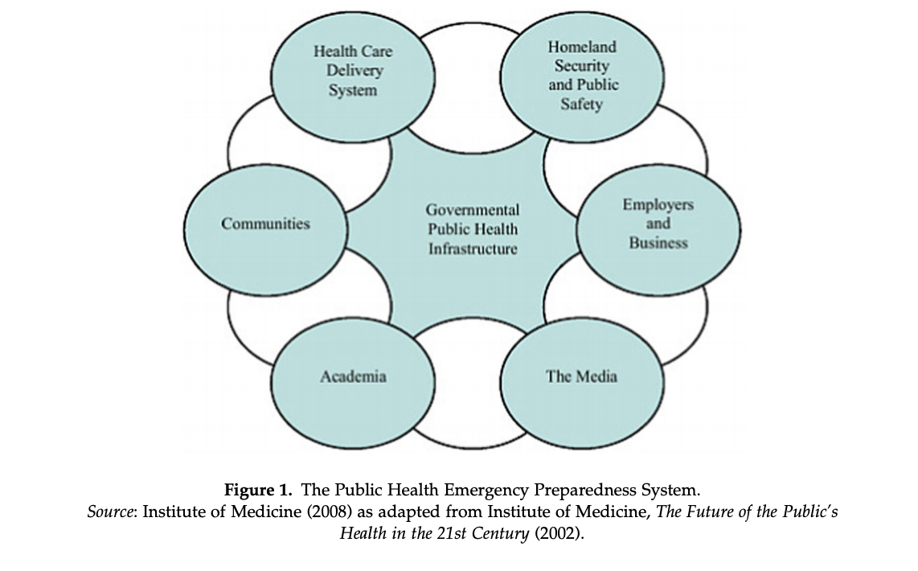

Conclusion
Each outbreak differs in biological agents, environmental causes, host characteristics, and risk factors, yet they serve to evaluate similar protocols from previous health threats. A successful approach to one health outbreak does not guarantee similar results with other diseases. For example, Ecuador totally eradicated ZIKA cases from their territory. Nonetheless, they are one of the most affected nations in the region from the COVID-19 pandemic. Latin America poses substantial structural issues to face a health epidemic and pandemics (resources, healthcare, personnel, and migratory push-factors).
Governmental structures also limit progress as shown by Venezuela in 2018 and 2019 which did not report ZIKA cases to the WHO and PAHO. The presence of thousands of stakeholders in the U.S. also creates a conflict of communication and accountability (federal agencies, non-state actors, medical doctors, local/municipal governments). Due to the large number of stakeholders in the US, it makes it difficult for the US to have a cohesive strong response to an outbreak, which is proving an issue during our current pandemic. Overall, health systems in the world arent prepared for a global pandemic because they lack cooperation in either the biomedical, communication and public policy strategies.
Therefore, it is important to understand the responses of the Zika outbreak and learn from the strategies that were implemented by Ecuador, the United States, and Venezuela. The reaction to the Zika outbreak demonstrated the importance of transparency, which ensures that governments report accurate cases of the outbreak to the international community. Transparency is an important reaction that Zika taught us, and must be utilized for future disease outbreaks and especially for our current situation with COVID-19 to combat the virus as a unified force.

ZIKA PROGRAM ECUADOR. (2019, February). Retrieved from https://www.usaid.gov/sites/default/files/documents/1864/Ecuador-Fact-Sheet-Feb-2019.pdf
Stewart Ibarra AM, Lowe R. Climate and non-climate drivers of dengue epidemics in southern coastal Ecuador. The American Journal of Tropical Medicine and Hygiene. 2013;88(5):971–981
“Zika in the US.” Centers for Disease Control and Prevention. Centers for Disease Control and Prevention, November 7, 2019. https://www.cdc.gov/zika/geo/index.html
Gutiérrez, Luis A. “PAHO/WHO Data - Weekly Report: PAHO/WHO.” Pan American Health Organization / World Health Organization, January 17, 2019. https://www.paho.org/data/index.php/en/?option=com_content&view=article&id=524:zika-weekly-en&Itemid=352.
Gutiérrez, Luis A. “PAHO/WHO Data - Weekly Report: PAHO/WHO.” Pan American Health Organization / World Health Organization, January 17, 2019. https://www.paho.org/data/index.php/en/?option=com_content&view=article&id=524:zika-weekly-en&Itemid=352.
Gutiérrez, Luis A. “PAHO/WHO Data - Weekly Report: PAHO/WHO.” Pan American Health Organization / World Health Organization, January 17, 2019. https://www.paho.org/data/index.php/en/?option=com_content&view=article&id=524:zika-weekly-en&Itemid=352.
Nieves, Evelyn. “Covering Zika in Hushed-Up Venezuela.” The New York Times. The New York Times, March 16, 2016. https://lens.blogs.nytimes.com/2016/03/16/zika-virus-venezuela-manu-quintero/.
“Sample Social Media Messages on Zika and Pregnancy.” Centers for Disease Control and Prevention. Centers for Disease Control and Prevention, February 26, 2019. https://www.cdc.gov/pregnancy/zika/materials/social-media-messages.html.
Ministerio de Salud Pública del Ecuador. (9 de Septiembre de 2016). Obtenido de https://www.salud.gob.ec/wp-content/uploads/2015/12/RESPUESTA-FRENTE-AL-ZIKA.pdf
A SOCIO-ECONOMIC IMPACT ASSESSMENT OF THE ZIKA VIRUS IN LATIN AMERICA AND THE CARIBBEAN: with a focus on Brazil, Colombia and Suriname. (2017). International Federation of Red Cross and Red Crescent Societies, 13–45. Retrieved from https://www.ifrc.org/Global/Photos/Secretariat/201702/UNDP-Zika-04-03-2017-English-WEB.pdf
Vtv. “Ministerio Del Poder Popular Salud Exhorta a Eliminar Criaderos Para Prevenir El Dengue.” Venezolana de Televisión, August 27, 2019. https://www.vtv.gob.ve/salud-eliminar-criaderos-dengue/.
ZIKA PROGRAM ECUADOR. (2019, February). Retrieved from https://www.usaid.gov/sites/default/files/documents/1864/Ecuador-Fact-Sheet-Feb-2019.pdf
“2016 Case Counts in the US.” Centers for Disease Control and Prevention. Centers for Disease Control and Prevention, April 24, 2019.
“Stakeholder Insights from Zika Virus Infections in Houston, Texas, USA, 2016–2017 - Volume 24, Number 11-November 2018 - Emerging Infectious Diseases Journal - CDC.” Centers for Disease Control and Prevention. Centers for Disease Control and Prevention.
Kovacs, K. (2016, October 3). Universities launch Zika prevention efforts in Florida and across the U.S. Retrieved from https://www.insidehighered.com/news/2016/10/03/universities-launch-zika-prevention-efforts-florida-and-across-us
“Expansión Del Zika No Se Detiene: En Venezuela Oficialmente Hay 4.700 Casos Sospechosos.” Efecto Cocuyo, May 25, 2019. https://efectococuyo.com/internacionales/expansion-del-zika-no-se-detiene-en-venezuela-oficialmente-hay-4-700-casos-sospechosos/.
1- Morain, Stephanie R., Catherine S. Eppes, Joslyn Fisher, Courtenay Bruce, Martha Rac, and Kjersti Aagaard. “Stakeholder Insights from Zika Virus Infections in Houston, Texas, USA, 2016–2017 - Volume 24, Number 11-November 2018 - Emerging Infectious Diseases Journal - CDC.” Centers for Disease Control and Prevention.
Centers for Disease Control and Prevention, November 2018. https://wwwnc.cdc.gov/eid/article/24/11/17-2108_article.
“United States Government Zika Virus Disease Contingency Response Plan.” U.S. Department of Health, September 2016. https://www.phe.gov/Preparedness/planning/Documents/zika-response-plan2016.pdf.
Lucio, Ruth, Nilhda Villacrés, and Rodrigo Henríquez. “The Health System of Ecuador.” Salud publica de Mexico. U.S. National Library of Medicine, 2011. https://www.ncbi.nlm.nih.gov/pubmed/21877083.
Margolis , Mac. “Covid-19 Is Trapping Ecuador Between Death and Debt.” Bloomberg.com. Bloomberg, April 8, 2020. https://www.bloomberg.com/opinion/articles/2020-04-08/coronavirus-traps-ecuador-between-death-and-debt.
Press, The Associated. “A Look at Who's Who in Ecuador's Deadly Political Crisis.” AP NEWS. Associated Press, October 11, 2019. https://apnews.com/cac5e2366a7e45cfa4e0dad27acbb475
Vasquez, Diego, Ana Palacio, Jose Nuñez, Wladimir Briones, John C Beier, Denisse C Pareja, and Leonardo Tamariz. “Impact of the 2016 Ecuador Earthquake on Zika Virus Cases.” American journal of public health. American Public Health Association, July 2017. https://www.ncbi.nlm.nih.gov/pmc/articles/PMC5463212/.
COMPLEX HUMANITARIAN EMERGENCY IN VENEZUELA.” Accion Solidaria National Report , September 2018. http://www.accionsolidaria.info/website/wp-content/uploads/2018/10/Venezuelan-CHE-Health-Sept-2018.pdf.
COMPLEX HUMANITARIAN EMERGENCY IN VENEZUELA.” Accion Solidaria National Report , September 2018. http://www.accionsolidaria.info/website/wp-content/uploads/2018/10/Venezuelan-CHE-Health-Sept-2018.pdf.
González, M. J., & Rincón Osorio, E. Venezuela la caída sin fin ¿hasta cuándo? Encuesta Nacional de Condiciones de Vida 2016 (ENCOVI 2016). Retrieved April 11, 2020, from https://encovi.ucab.edu.ve/wp-content/uploads/sites/2/2018/02/encovi-2016-venezuela-la-caida-sin-fin-hasta-cuando.pdf (2016)
Raphelson, Samantha. “Venezuela's Health Care System Ready To Collapse Amid Economic Crisis.” NPR. NPR, February 1, 2018. https://www.npr.org/2018/02/01/582469305/venezuelas-health-care-system-ready-to-collapse-amid-economic-crisis.
Raphelson, Samantha. “Venezuela's Health Care System Ready To Collapse Amid Economic Crisis.” NPR. NPR, February 1, 2018. https://www.npr.org/2018/02/01/582469305/venezuelas-health-care-system-ready-to-collapse-amid-economic-crisis.
“COMPLEX HUMANITARIAN EMERGENCY IN VENEZUELA.” Accion Solidaria National Report , September 2018. http://www.accionsolidaria.info/website/wp-content/uploads/2018/10/Venezuelan-CHE-Health-Sept-2018.pdf.
Oroperza, V. (n.d.). La escala de la malaria en Venezuela. Retrieved March 30, 2020, from http://factor.prodavinci.com/escalademalaria/index.html
“COMPLEX HUMANITARIAN EMERGENCY IN VENEZUELA.” Accion Solidaria National Report , September 2018. http://www.accionsolidaria.info/website/wp-content/uploads/2018/10/Venezuelan-CHE-Health-Sept-2018.pdf.
“COMPLEX HUMANITARIAN EMERGENCY IN VENEZUELA.” Accion Solidaria National Report , September 2018. http://www.accionsolidaria.info/website/wp-content/uploads/2018/10/Venezuelan-CHE-Health-Sept-2018.pdf.
Sarmiento, Juan Pablo. Director, Disaster Risk and Resilience in the Americas (DRRA), Associate Director for Research, Extreme Events Institute, Florida International University. Personal Interview, (March 2020).
Rodriguez-Acosta, Cristina. Assistant Director Jack D. Gordon Institute, Florida International University, Personal Interview, (April, 2020).
Espinal, Carlos, Director Global Health Consortium, Personal Interview, (March 2020).
Department of Homeland Security. Zika virus: DHS response plan. Jan 11, 2016. Available at: www.dhs.gov/news/2016/02/11/zika-virus-dhs-response-plan.
Department of Homeland Security. Zika virus: DHS response plan. Jan 11, 2016. Available at: www.dhs.gov/news/2016/02/11/zika-virus-dhs-response-plan.
Reuters. Florida governor declares health emergency in four counties over Zika. Feb 3, 2016. Available at: www.reuters.com/article/us-health-zika-florida-idUSKCN0VC2S9.
Centers for Disease Control and Prevention. Florida investigation links four recent Zika cases to local mosquito-borne virus transmission. Jul 29, 2016. Available at: www.cdc.gov/media/releases/2016/p0729-florida-zika-cases.html.
Centers for Disease Control and Prevention. Florida investigation links four recent Zika cases to local mosquito-borne virus transmission. Jul 29, 2016. Available at: www.cdc.gov/media/releases/2016/p0729-florida-zika-cases.html.
Department of Homeland Security. Zika virus: DHS response plan. Jan 11, 2016. Available at: www.dhs.gov/news/2016/02/11/zika-virus-dhs-response-plan.
WHO. Protecting Humanity from Future Health Crises. Report of the High-level Panel on the Global Response to Health Crises. (Preliminary) WHO, Geneva, 26 January 2016. WHO. http://www.who.int/mediacentre/news/statements/ 2016/1st-emergency-committee-zika/en/
WHO. Protecting Humanity from Future Health Crises. Report of the High-level Panel on the Global Response to Health Crises. (Preliminary) WHO, Geneva, 26 January 2016. WHO. http://www.who.int/mediacentre/news/statements/ 2016/1st-emergency-committee-zika/en/
Goodfellow I, Reusken C, Koopmans M. Laboratory support during and after the Ebola virus endgame: towards a sustained laboratory infrastructure. Euro Surveill 2015 Mar 26;20(12). pii: 21074.
Goodfellow I, Reusken C, Koopmans M. Laboratory support during and after the Ebola virus endgame: towards a sustained laboratory infrastructure. Euro Surveill 2015 Mar 26;20(12). pii: 21074.
Ndihokubwayo JB, Kasolo FN, Yahaya AA, Mwenda J. Strengthening Public Health Laboratories in the WHO AfricanRegion: A Critical Need for Disease Control. Report World Health Organization Regional Office for Africa.; 23 March 2015 (https://www.aho.afro.who.int/sites/default/files/ahm/reports/20/ ahm12pages47to52.pdf
Goodfellow I, Reusken C, Koopmans M. Laboratory support during and after the Ebola virus endgame: towards a sustained laboratory infrastructure. Euro Surveill 2015 Mar 26;20(12). pii: 21074.
United Nations. Protecting Humanity from Future Health Crises Report of the High-level Panel on the Global Response to Health Crises (http://www.un.org/ News/dh/infocus/HLP/2016-02 05_Final_Report_Global_Response_to_Health_ Crises.pdf)
United Nations. Protecting Humanity from Future Health Crises Report of the High-level Panel on the Global Response to Health Crises (http://www.un.org/ News/dh/infocus/HLP/2016-02 05_Final_Report_Global_Response_to_Health_ Crises.pdf)

