Countering Chinese Influence Operations in Australia and Differentiating the United States as Australia’s Partner of Choice

Kamila Arap, Andres Eskenazi, Daniela Valdes, Ashley Weathers

IDH 3034: Diplomacy Lab
Professor Brian Fonseca
November 24^{th,} 2019

Executive Summary
In Australia, United States policy-makers should prioritize security cooperation programs and increased diplomatic communications, in order to mitigate China’s predominantly educational, economic, and political activities. The purpose of this research is to measure the effectiveness and success of security cooperation with Australia as a mechanism to become the nation’s partner of choice. This research project would be divided into four categories based on the instruments of national power or ‘DIME’ (defense, intelligence, military, and economics).
Diplomatically, both the United States and Australia encounter the problem of Chinese political interference in the form of campaign financing and abuse of a Chinese Australian diaspora. The Chinese employment of political soft power needs to be counteracted through security measures explained in the Security section of this paper as well as through the improvement and advancement of US-Australia diplomatic relations. In the information sphere, further speculation arises from China’s fusion of military-civil policy and national intelligence legislation fusing commerce and enterprise with military intelligence.
In the realm of security cooperation key factors to focus on are: military sales/hardware cooperation, strategic security engagement, institutional building, and multilateral exercises and operations. The research would be separated into two categories based on Chinese and American effectiveness in the security area in Australia.

Background
With China rising as a global power, one of the concerns arising for the United States is that China’s growing power will undermine that of the US. China is already one of the world’s leading economic powers and it has started to attempt to become more influential in the global space. This is seen in China’s endeavor into forming and or strengthening a Chinese sphere of influence in the Asia Pacific region. Australia, being located in the region, has become a subject of interest for China. The Chinese pursuit of influence in Australia has taken many forms, including diplomatic, security, information and economic interference. The Australian government and people have expressed worry towards the possible impact the Chinese could have on Australian security and democracy. This also makes the United States uneasy as China’s influence in Australia could cause Australia to stray away from their partnership with the United States. The geographical closeness of the nations and China’s impressive economic power may encourage Australia to move towards more Chinese friendly policies in favor of US friendly policies (Kissel).
Historically, the United States and Australia have a long past of bilateral partnership. The cultural kinship has provided a basis for the relationship between the nations and it is in the United States’ best interest to remain Australia’s number one partner of choice. The influence that these two countries have had on each other has been tremendous, with there being a deep collaboration between governments in terms of “foreign policy, defense and security, intelligence, development, energy, environment, education, law, trade and investment.” (Australia and the United States Relations.) This cooperation creates a mutually beneficial relationship for Australia and the United States.
The effort that China is exerting in the competition to be Australia’s number one partner of choice must be matched if not exceeded by the United States. To do this, the United States must advance and make changes in certain areas of influence, such as improving diplomatic relations, offering security assistance and spreading pro-US telecommunications.

Diplomacy
Due to the Chinese government’s comprehensive acquisition of political soft power in Australia, it is crucial that the United States improve its diplomatic relationship with Australia in order to maintain the US’s role as Australia’s number one partner of choice.
The United States and Australia have strong diplomatic ties, cooperating with one another for over 75 years. The firm alliance between the two countries has played out in wars, economic agreements, and just an overall partnership. Australia is an essential ally for the United States as they hold similar values and culture. The geography of Australia is also pertinent as its location in the Indo-Pacific region and its US alliance helps to establish a more stable and free region. The rise of Chinese influence in the diplomatic field of Australia could threaten the partnership between the United States and Australia by causing the creation of policies that do not benefit the United States and its agenda. Previously, the relationship between Australia and China was not a friendly one, as the differences in cultural values and the US-Australia alliance prevented a fully bilateral and mutually beneficial relationship between the countries. However, China’s rise as an economic and global power has made it more appealing in terms of agreements and alliances.
Former Appointees working with China
Former Australian Prime Minister Abbott was keen on working with China because of their rising economic power. He believed American politics could be “unstable”, as said in an interview. The interview was interesting as it was very clear that Abbott was all for Chinese partnership with Australia, even if that meant the decline of American-Australian Partnership. Abbot seems to believe that a partnership with China could only be helpful, specifically because of their tremendous economy. He also states that he wishes to continue working with the United States but that one of his issues is that America is kind of unpredictable. He believes America “goes through periods of doubt and introspection. and this may be one of them.” (Kissel). The allure that China is giving off is becoming dangerous as it diminishes US appeal and may cause Australia to choose to work with China instead of the United States in the future.
Campaign Interference
Another example of how China is interfering with Australia's politics is through campaign financing. “Australian Politics Is Open to Foreign Donations, and China Has Much to Gain” mentions a report that proved that two businessmen of chinese descent have been steadily contributing to campaigns in recent years. (Cave) The Australian government is trying to combat this issue by creating more rules in terms of campaigning but there is still a ways to go. Another interesting fact this article brought up was that the United States wanted Australia to send naval patrols to the South China Sea to challenge Beijing's claim and Australia refused.
Chinese Diaspora
Australia’s chinese diaspora consists of all people who are legally considered Australian but have some sort of tie to China, be it direct or familial. This creates a loyalty and sympathetic nature for these Australians when it comes to China and it is possible that a part of the problem is that China might be taking advantage of the Chinese-Australians and persuading them to make political decisions that would be more China friendly. Although it may be that it is just the nature of their roots that would cause Chinese Australians to vote in ways that benefit Chinese policies and it may not have been because of influence from China (Laurenceson). JIA GAO explains that the supposed influence is due to both Australian political parties looking to up membership and appealing to Chinese Australians. Consequently, the further integration of Chinese Australians into the major parties has shifted the political field towards a more Chinese sympathetic route.
Policy Recommendations
Schaefer’s article suggests that a good way to maintain the US as Australia's partner of choice is to help expand relations between Australia and neighboring countries that are US allies, like Japan and South Korea. This can perhaps be done through encouraging economic relations with US allies as well as partnerships between non-governmental organizations that are based in Australia or other US-allied nations.
Key leader engagement is imperative in strengthening United States and Australian relations as discussions between leaders can lead to new policies and further agreements between the nations. It also works for showing Australia that the United States is invested in their partnership and is willing to create more ties between the countries. Engagement between leaders that are not the heads of state can also be helpful as it demonstrates the desire to continue to work with Australia no matter who is in charge of the country.
Information
Because of increasing Chinese Intelligence capabilities in the region of Oceania, the United States needs to pivot pacific policy to focus on the Australian continent. China has been advancing in the region because of their educational initiatives with other countries, military sales and strong engagement in telecommunications industry. However, The United States has an upper hand with Australia because of the Five eyes alliance, and the massive arms exports between both countries.
Commerce Legislation
The installment of a comprehensive internet security and surveillance program to provide “full coverage” of inter web activities for the entire country, is one that is putting both American and Australian companies at risk. Under the new Chinese system, trade secrets are not permitted. This means that U.S. and EU companies operating in China will now need to assume any “secret” they seek to maintain on a server or network in China will automatically become available to the Chinese government and then to all of their Chinese government controlled competitors in China, including the Chinese military. This includes phone calls, emails, WeChat messages and any other form of electronic communication. Since no company can reasonably assume its trade secrets will remain secret once transmitted into China over a Chinese controlled network, they are at great risk of having their trade secret protections outside China evaporating as well.
Education Initiatives
China and Australia have been promoting Educational Programs with Australia’s Ministry of Education through the New Colombo Plan. It is a regional plan initiated by the Australian government to promote cultural and educational exchanges in the Indo-Pacific region. Since 2009 well over 12,000 students have participated and gone to China to study. Over 25 institutions in Australia are working with 40 institutions in China since 2015 to promote more student exchanges. The rise in regional cooperation between Asian countries like China, instead of the western pacific region of the globe like the United States and Latin America does not look favorably upon future relations between the continent of Australia and the USA.

Telecommunications Industry
Furthermore, Chinese intelligence and cyber initiatives primarily steal information from other countries through corporate partnerships. Since China passed a National Intelligence Law stating that all people and organizations must cooperate in espionage work, making Huawei their prime source of espionage. In result of this, Australia was one of the first countries to ban a $38 billion contract with Huawei to build a 5G network, and are dissuading India from doing so as well. However, this has not stopped other huge Chinese industries to enter Australia, especially after the signing of ChAFTA (Chinese-Australian Free Trade Agreement) in 2014.
Results & Recommendations
In 2018, Australian Prime Minister Malcolm Turnbull came out with a new Australian foreign policy strategy of having Australia become one of the largest exporters of military equipment in the world. Australia has a very vulnerable geographic location by the South China Sea, but still maintaining huge military and Intelligence alliances with Western powers. This requires that they become a key player in military game for future possible conflict.
This is where the United States comes in to play. The United States and Australia are and have been very strong partners in military alliances. The US military has access to all major ADF training areas, including northern Australian RAAF airfields, port facilities in Darwin and Fremantle. In 2018, the United States imports the second largest amount of military weaponry to Australia ($918 million), with Saudi Arabia as the first ($3.35 Billion). Coming into 2019-2020, This amount should be higher, with Australia being one of our most competitive partners in military weaponry and training. An increase of military rapport combined with joint efforts from the FIVEY (five eyes intelligence alliance) to focus on figures in South East Asia and more specifically China, would be a strong and deterrent mode of operating in the Area

Economic
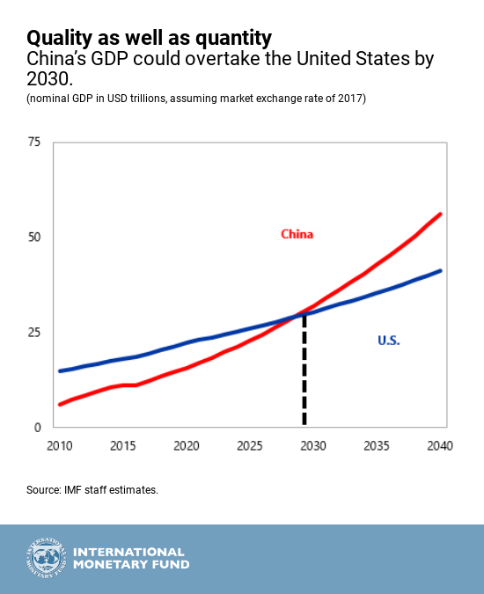
The economic aspect of Chinese competition to the United States is at the forefront of securing Australia as an ally. As China progresses in the world economic stage, it is clear that it will overtake the United States by 2030 in the current economic predictions. Securing allies, such as Australia, is vital for the sustainability of the US economy and maintaining ourselves as the most competitive economy in the world.

IMF: China’s Projection to Overtake the US Economy by 2030
Source: International Monetary Fund’s Chinese Economic Predictions

Chinese Investment in Australia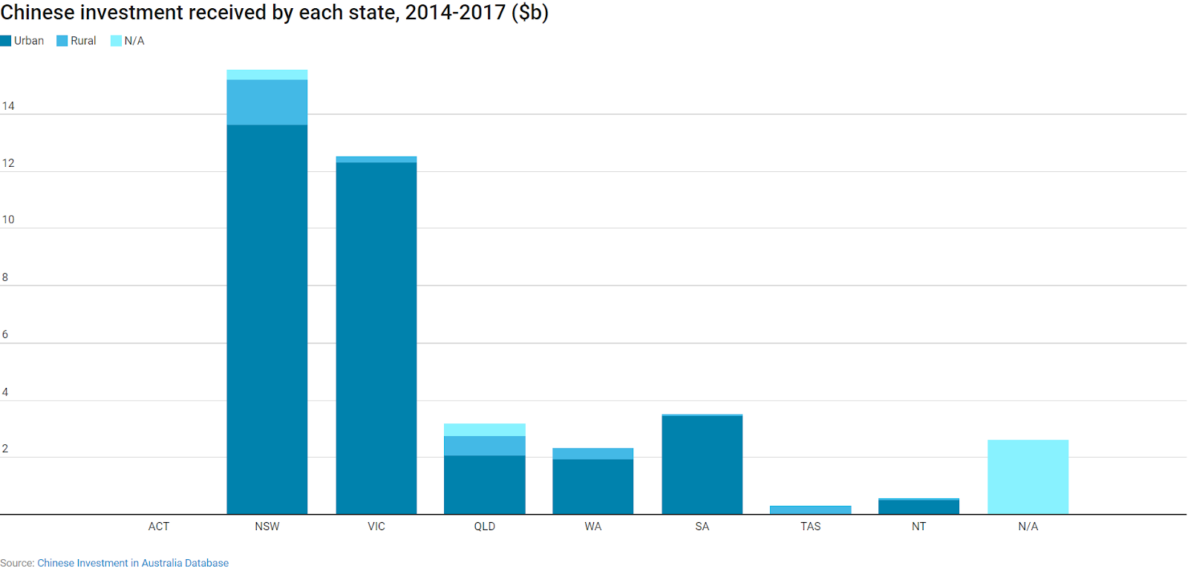
Source: Chinese Investment in Australia
As we observe the investment trends of China in Australia, we see that from 2014 to 2017 Chinese investment totaled more than $40.4 billion. Most of these investments go towards real estate, transportation, and mining, with mining composing a fourth of of investment over a four year period. Another growing sector for Chinese investment is the services sector, which includes the health service industries. While studies have shown that only 20% of this investment comes from state-owned enterprises, it is a nearly equivalent threat to have this private sector Chinese investment abroad.
China’s One Belt One Road (initiative) has swept across Europe, Asia, Oceania, and Africa to promote Chinese accessibility to trade with various nations. The Australian Government clearly states,“The purchase and construction of port facilities and associated economic zones in Australia are intended to provide China with maritime access and economic benefit across the Indian Ocean. These will connect to Piraeus, Greece’s major port, which has been bought by Chinese shipping group COSCO and which will allow direct access to the markets of Europe.” China’s ambitions in Australia go far beyond their individual relationship. Australia is simply a step within China’s greater plan for economic development and influence in the eastern hemisphere.
While many Australians see the threat of Chinese influence and recognize its potential to endanger national security, others see these investments as a potential launching pad for Australian economic prosperity. While the future of China is incredibly hopeful, some Australians believe that an alliance with China is one that they should start early in anticipation of their economic dominance. Investment is one of the most direct ways that China gains and maintains influence within the lives of Australians.

Lease of Port Darwin
In just 2015, Landbridge Industry Australia (a subsidiary of Shandong Landbridge Group) purchased a 99-year lease for Port Darwin in the Northern Territory of Australia for $343 million USD. Landbridge Industry specializes in port logistics, petrochemicals, timber and real estate development in China. Additionally, the company closely works alongside state-owned sectors such as the China National Petroleum Corporation, the Chinese Communist Party, and the People’s Liberation Army.
The Legislative Assembly of the Northern Territory stated on the topic of a potential lease, “It nevertheless also notes the strategic position of the Port of Darwin and considers that no investment should occur that threatens the strategic or security interests of Australia.” Although the acknowledgement of Darwin’s strategic importance is paramount, the Australian government has put its Northern territories at risk by leasing to such a company. With the corporation’s CEO, Ye Cheng, being named by the Chinese Government in 2013 as a top 10 citizen for “caring about the development of national defense,” this provides a large risk factor for Australian security.
As one of the most fundamental strategic locations for the potential expansion of China’s One Belt One Road(OBOR) initiatives in Oceania, Port Darwin is a huge asset for the Chinese government. Through this investment, we will surely see the long-term effects of Chinese influence directly on the soil of Australia. This lease not only threatens the safety of Australian citizens, land, democracy, and information, but it also threatens for surveillance of the US.

China-Australia Free Trade Agreement (ChAFTA)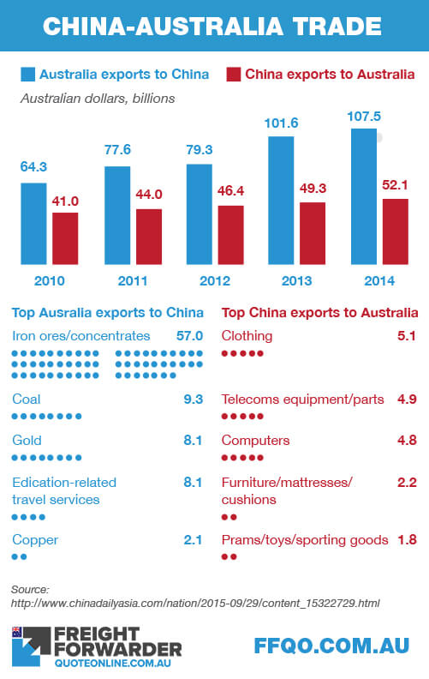
Australia’s largest trading partner has been China for numerous years. According to the Australian Government, “Trade and investment with China is central to Australia’s future prosperity.” In 2017, China bought about $116 billion of Australian exports, which composes more than a quarter of Australia’s total exports to the world. Alongside these frequent purchases, Chinese investment in Australia reached $65 billion by the end of 2017. Due to these factors, China and Australia composed the China-Australia Free Trade Agreement which was signed on June 17, 2015 and entered into force on December 20, 2015.
This trade deal resulted in 7,289 individual Chinese tariffs being cut, or eliminated completely after the first round of changes. Additionally, China is by far Australia’s largest market for resources and energy products. Australia exported over $85 billion worth of resources, energy and manufactured products to China in 2015. Through ChaFTA, the Australian energy sector was able to utilize duty-free entry into the Chinese economy. The services sector in Australia also relies on a large Chinese market, which was composed of $15.8 billion in exports in 2017.
Within ChAFTA, there is a featured Most-Favoured Nation (MFN) clause, under which Australia is guaranteed a competitive position in services into the future. This is specifically to be utilized if China offers a more beneficial treatment to other trade partners in the following sectors: education, tourism and travel-related services, construction, engineering, securities, environmental services, services relating to forestry, computer and related services, and certain scientific and consulting services.
Within the MFN clause, there is even more of a complication to how the United States may pursue a better relationship with Australia. As we have witnessed Australia create numerous ties to the Chinese economy, it has been made clear that China will not be leaving the Australian economy any time soon. The influence of ChAFTA has only clarified and strengthened the dedication of Chinese-Australian relations.
Why China?
The People’s Republic of China has maintained an intense trading relationship with Australia through numerous tactics over the past years. Not only do the Chinese provide engaged markets for Australian sectors, but they invest the most money into Australia by far. Rather than solely directing a fragmented plan towards Australia, China manages to make Australia see a watercolor painting of their future with China. By including the potential stance of Australia in relation to China as well as their allies, they are able to realistically see how a relation with China would be a relationship with many. In addition to this, China has the most strategic location to trade with Australia. By their close proximity, China can ship goods to Australia for a cheaper price than their competitors. ChAFTA even further secured lower prices between the two countries to promote their strong alliance.

Conclusion
As expressed in all previous sections, China continues to play a large role in industrial, educational, military and political sectors of Australia. Because this is a relatively new Chinese foreign policy strategy stemming from 21st century domination tactics, the United States needs to strongly consider playing “the long game” in Australian-Pacific relations to overcompensate for Chinese involvement in the region. Ultimately, through long term contracts of arm sales, increased intelligence and media exchange/sharing between the USA and Australia, as well as more key leader engagement and the encouragement of agreements between Australia and nearby US allies, the influence that China is gaining in the Indo-Pacific region will be stopped in its tracks.

Background
China has emerged as a powerhouse in the south pacific by expanding many of their industries, moving their culture abroad and information dissemination tactics. The continued advances in these dual-use strategies may be leveraged for future military applications pursuant to a national strategy of military-civil fusion. At this point, the trajectory of their developments is uncertain, and considerable challenges remain to the actualization of deeper fusion of China’s defense and commercial sectors. However, if successful, China’s ambitions to lead in these strategic technologies could enable it to pioneer new forms of military power in Oceania.

Figure 1 Heroines, “Three-fold screen with embroidered panels depicting heroines. Designed by

Works Cited (this is bold) (start on a new page)

